NAJUA 2015 Nominations Vita Form

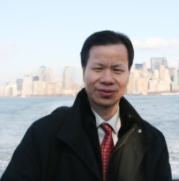 | Nominee Name: Zhu, ShuiPing (朱水平)  Position for Nominee: VP North Central  Region: Chicago

Experience (indicate professional, community, and university experience):
10 year teaching in Wuhan Institute of Chemical Industry.
15 year R&D work in chemical companies of Unilever, Arkema, Stepan etc.

Education (indicate institutions, degrees, year, and major fields):
1995-1998: Ph.D. Department of Physics, Nankai University
1983-1986: M.S. Department of Chemical Engineering, Jiangnan University
1979-1983: B.S. Department of Chemical Engineering, Jiangnan University

Statement (Vision and Ideas regarding the position nominated with NAJUA):
Organize/coordinate the relationships and activities for alumni in North Central area;
Participate in the leadership work of NAJUA;
Propose or pass over suggestions;
Work with others to make alumni’s life and work more interesting in NA.
组织与协调本区校友的联络与活动，参与北美校友会的领导工作，提议并转达其他校友的建议，与大家一起努力使北美校友的生活和工作更有情趣。

I have discussed the responsibilities of the position with a Nominating Committee member so that I am fully informed of its responsibilities.

Nominee__________________ 6/22/2015 _ _
Signature Date

NOTE: Additional sheets may be attached.

